Comparative evaluation of two systems
for integrating biometric data from self-quantification

Bibin Punnoose and Kathleen Gray

University of Melbourne, Melbourne, Victoria, Australia

kgray@unimelb.edu.au

Abstract. A layperson can accumulate a large volume of biometric data using the self quantification tools available in the consumer electronics market. However to derive insight, one must be able to integrate data types in order to identify patterns that emerge. This paper compares the practicalities of integrating biometric data from self-quantification, using the TicTrac and HealthVault integration tools. The techniques needed to use such tools may be challenging for many consumers. The aggregated data may have data quality issues. These factors limit the realization of benefits for individual or population health.

Keywords: consumer health informatics, Health Vault, Quantified Self, self-tracking, TicTrac

- Background and aim

In self-quantification, a layperson can select from a variety of non-standardized consumer electronic devices to measure, record and represent data about their body – biometric data – including one or more of: blood chemistry, blood pressure, body temperature, body weight, heart rate, mood and brain activity, respiratory rate and sleep pattern. These wearable sensing and feedback systems are thought have the potential to produce significant health benefits for individuals and populations (for example, Lupton, 2013; Swan, 2012).
A person can accumulate a large volume of biometric data using self quantification tools such as: Adidas miCoach, Amiigo, Basis, Blipcare, Bodymedia, Cardiio, Emwave2, Fitbit, Happiness, InsideTracker Lark, Jawbone Up, MercuryApp, Mio, Misfit Shine, Moodjam, MoodPanda, Moodscope, Moves, Myithlete, Nike Fuelband, iHealth, Omron, Polar, RunKeeper, SleepCycle, Strava, Talking20, Tinke, Wakemate, WellnessFX, Withings and Zeo (Technori, n.d). Their use varies according to whether they are static, mobile or wearable; whether they are designed to connect to software on a desktop or laptop computer, to a tablet or smartphone app, directly to a web site or to another device, and whether they need a cable, Bluetooth or Wifi. While some self-quantification tools merely collect and accumulate biometric data, others offer different approaches to integrate and visualize the collected data.
It is hard to derive much insight into health from viewing different biometric data sets separately, as compared to seeing them in relation to each other (Tilahun, 2014). Although recommendations for designing systems to integrate such data using online platforms have been around for some time (Frost 2008), in most cases this still requires a separate set of tools (Almalki et al., 2013), for example Microsoft Excel, Indiemapper, Nineteen, Tictrac (Technori, n.d). Some tools originally designed as a Personal Health Record (PHR) - an electronic application for a member of the public to store all their health data in one place - now offer this functionality, for example Microsoft HealthVault (HealthVault, 2014).
Comparative evaluation of the performance of such tools could be useful to health self-quantifiers and those who work with them. The aim of this paper is to compare the performance of a generic life-logging tool and a personal health record tool for this purpose.

2 Method

Two free online tools were chosen. HealthVault, a PHR, can store a wide variety of data besides biometric data - allergies, appointments, disease conditions, contacts, family history, immunizations, etc. Tictrac, a platform to track lifestyle information grouped under health, wellbeing, entertainment, family, finance, fitness, and social projects, can include data from health and fitness related projects to projects related to daily activities like television watching and holidays (Tictrac, 2014).
This study was undertaken as a self-experiment by one researcher with advice and feedback provided by the other researcher. Since self-quantification is essentially self-experimentation (Fox, 2013), this method was an apt reflection of real-world use of the tools. Further, self-experimentation has been reported previously in this type of research (Smarr, 2012).
Over a four week period, one researcher collected and integrated biometric data routinely in both TicTrac and HealthVault. In addition, the researcher separately maintained a daily log of activities and experiences while using these tools and integrating the data. Four devices widely available in the Australian consumer electronic market were used to collect data:
LARK sleep monitoring system uses the wrist band and an app to record sleep data. The app used was an iOS 8 compatible app of apple devices to monitor sleep data. The wristband was connected to a dock for charging. The alarm time had to be set on the iPad first, turned ‘on’ and then the wristband removed from the dock and tied on to the wrist. This will activate the system and start recording sleep data from the moment it is disconnected from the dock until the alarm is turned ‘off’. The alarm is a silent and vibrating alarm. The data recorded include total hours of sleep, number of times woken up, duration to fall asleep and sleep quality rating (LARK, n.d.).
Fitbit Atria is an electronic weighing scale used to record a person’s weight. This device was connected to the local wifi with the help of a computer connected to the same wifi. An account was created in the Fitbit website. Each time the weight was measured, the weight was transmitted through the wifi to the account and it automatically gets updated. (Fitbit, n.d.).
The Polar loop wristband was used to collect the data about daily activity. The data collected was recorded in the Polar Flowsync account by connecting the wristband. This was easy to create and was done using a windows computer and an android based smart phone. The wristband was worn all day until going to bed. The data recorded includes: number of steps walked, number of calories burnt, and duration of activity. It also shows time just like a digital watch. The wristband was connected to the laptop using a USB cable and data was transferred to the account. The transfer of data could also be done by opening the app on the mobile and pressing the button on the wristband to enable Bluetooth connection (Polar, n.d.).
The iHealth Non-Invasive Blood Pressure (NIBP) equipment and iHealth app was used to collect data about the blood pressure and heart rate. The app was downloaded on to an iPad using iOS software and an icloud account was opened. The NIBP equipment was connected to the iPad and controlled through the device via Bluetooth to enable inflation of the cuff. The data collected was saved onto the user’s account. (iHealth, n.d.)
Tool performance was compared in terms of usability (a process criterion) and visualization (an output criterion). The approach taken to usability evaluation was the technique of user performance testing, that is, a study conducted on fully complete equipment by a real-life user (Shackel, 2009). The framework for determining usabililty was based on the perspective of an end user, where effectiveness and efficiency are pragmatic goals and user experience is a hedonic goal (Bevan, 2009). Information visualization was evaluated using the cognitive efficiency model of graphical design, which brings together four concepts (Hullman, 2011): data-ink ratio; information organization; animation; and labelling.
Descriptive data analysis was done by thematically reviewing the content of the log, and by inspecting the resulting visual artifacts that were created using each integrating tool. Themes for data analysis were based on the measures of usability and visualization that were identified from the literature.

3. Findings

3.1 Visualization

In Tictrac biometric data can be viewed as summary of the data up to a date or as a time breakdown as to when the data was recorded each day, or as a line graph (Figure 1); in the latter, all four data sets can be represented with a different colour and viewed simultaneously on the same chart ( Figure 2). The data-ink ratio in the line graph is high because the data occupies the majority of the ink viewed in the chart. The Information organization is done by having one half of the project page blank where data sets can be dragged one by one for viewing as a summary or a trend or as circular breakdown chart and the other half with tiles of biometric data with their latest readings. It also shows a dropdown box to view as days or weeks or months. Animation of data is not used. The labeling of dates is done by pop-up of the values of the biometric data when a pointer is placed on the node corresponding to each date
In HealthVault, biometric data are shown as tiles with the names of the data types and their corresponding last reading. Clicking a tile displays all the biometric data from the latest collected. Another tab next can be clicked to view the data as a line graph (Figure 3); however it is not possible to see multiple data trends in one screen simultaneously. The data- ink ratio in the line graph is low in comparison to Tictrac; the majority of the ink viewed in the chart includes the grid lines shown to represent date and value of data, but the information gained is not more than that obtained from the Tictrac chart. The grid lines give an approximation but are not accurate (Bhandari, 2012). Information organization is done using the tabs and tiles; a dropdown box shows days or weeks or months similar to Tictrac. This gives clear insight to the user as to the progress made in each timeframe (Bhandari, 2012). Labelling is done here much more than Tictrac, not only representing dates and but also the values of the data. As with TicTrac, the pointer when placed on the node corresponding to each date shows the data value as a pop-up. There are no legends used in this chart, similar to Tictrac. As with TicTrac, no animation is used.

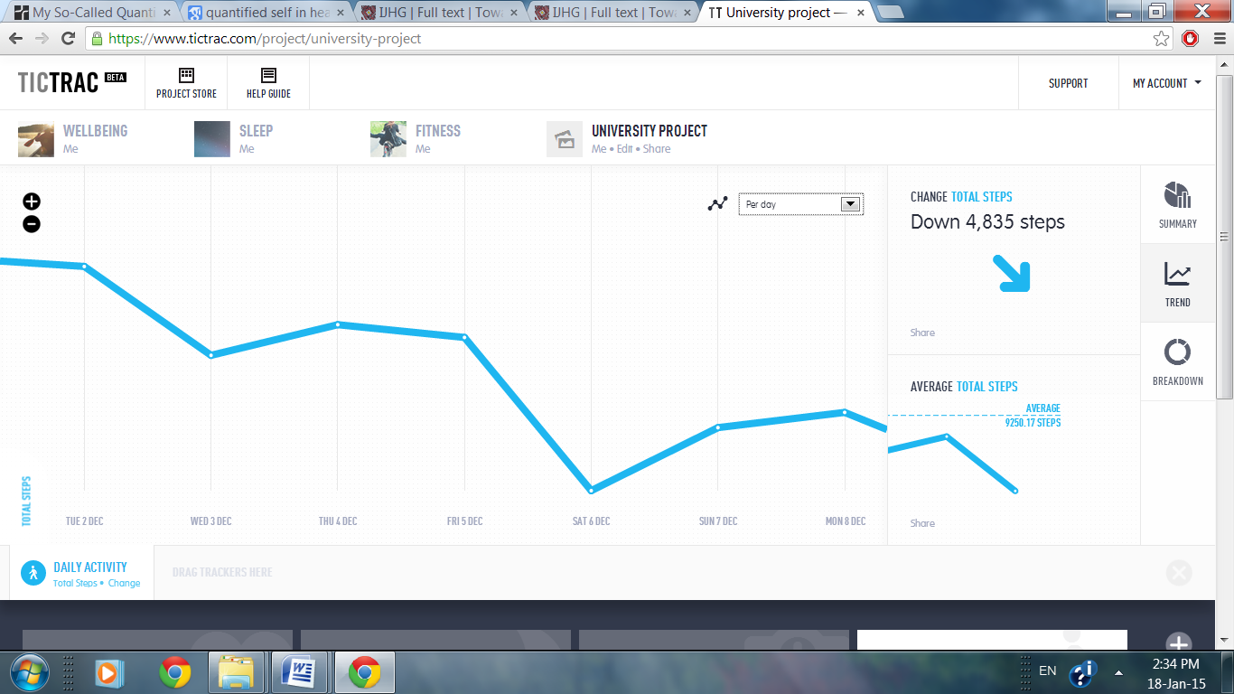
Fig 1. Screenshot of weight trend in Tictrac

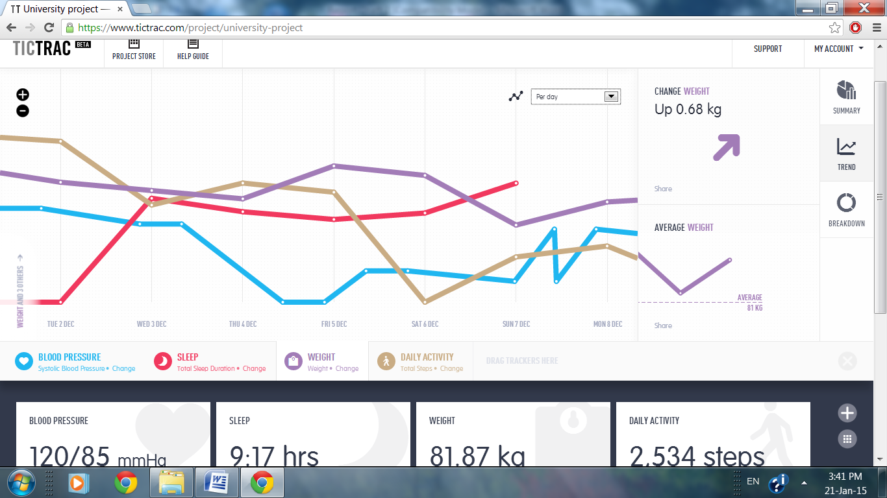
Fig. 2. Screenshot of combined biometric data trends in Tictrac

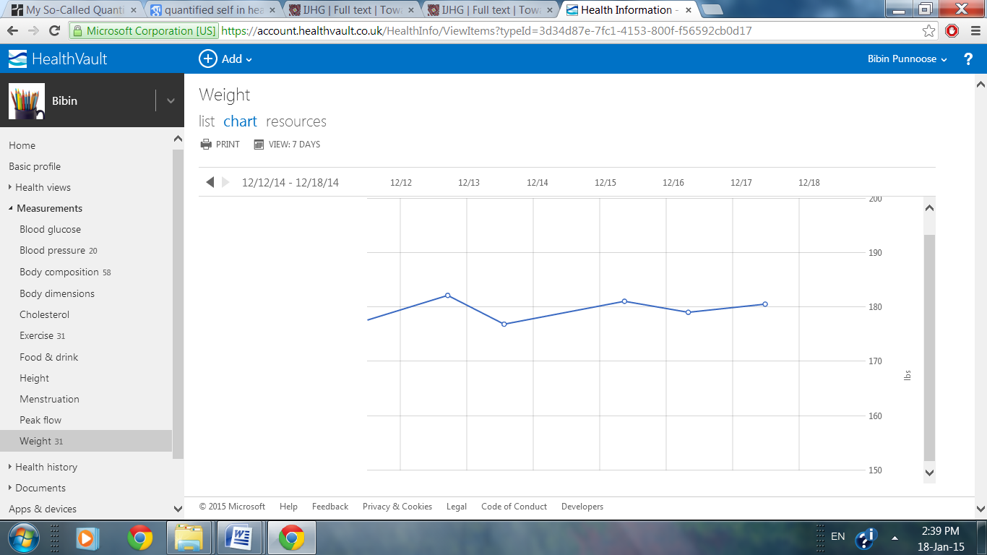
Fig. 3. Screenshot of weight trend in HealthVault

3.2 Usability

In terms of Tictrac effectiveness, the integration of data into the account happened automatically for data from the Fitbit and iHealth apps, once they were connected to Tictrac. However, integration had to be done manually by the user for data from LARK and Polar flowsync devices; the Tictrac account had a format to store these data and the user had to type the readings in. In terms of efficiency, the only time expended on Fitbit and iHealth data was a one-time task to set up this connection, as opposed to the LARK and Polar flowsync apps where logging into the Tictrac account was necessary and then the data had to be entered manually each time the user chose. The average time taken for logging into the account was 25 seconds, 40 seconds per entry for entering activity data and sleep data. The time taken to check an entry on weight and blood pressure was 20 seconds. In terms of satisfaction Tictrac was effective, efficient, and easy to navigate.
In terms of HealthVault effectiveness, the integration of data from the Fitbit app happened automatically once it was connected to the system. The integration of data from iHealth and Polar Flowsync tools had to be done manually by the user; there was a format to store these data and the user had to type the readings in. In the case of LARK, it could neither be connected automatically nor did it have a format to enter the readings. HealthVault had the option to export and import data as an Excel spreadsheet but LARK did not have the option to export data; so the work-around used to was to enter LARK data into Tictrac, export them from Tictrac and then import them into HealthVault. In terms of efficiency, although HealthVault can integrate Fitbit data automatically, as opposed to Tictrac it is not a one-time process: the time expended included the time spent to set up the initial connection; in addition each time the user wanted to integrate the data it was necessary to log into the HealthVault account and go to the Fitbit page and click ‘post’. The user had to log into the account each time also to do iHealth and Polar flowsync data entry. The average time taken for logging into the account was 30 seconds, 40 seconds per entry for entering physical activity data and 30 seconds per entry for entering blood pressure data. The time taken to check an entry in weight was 40 seconds. Sleep data entry checking was extenuated by the process described above. HealthVault was effective to some extent, and it was very simple in format and appearance, but it was less time-efficient than Tictrac, so overall it produced lower user satisfaction than Tictrac.

4. Discussion and conclusions

The researchers acknowledge that the study findings might not be the same for a larger sample of users and data sets, however the use of self-experimentation method had advantages in terms of rapidly and efficiently outlining protocols for conducting a larger study of data collection and integration tool performance.
Several lessons emerged from the experience of working with the two integration tools compared in this study. An integration tool should be able to: interface with the all of the biometric data collection devices used, or at least have appropriate data fields; display data as a graph or a summary, and offer comprehensive and detailed versions of each type of view; and exchange data with other health- and self-management tools.
Usable tools, properly used, can allow individuals to discern biometric data patterns that may help them to set and achieve health improvement goals, with flow on benefits to population health. However, while most tools for collecting a particular type of data follow the same straightforward method irrespective of the brand of tool (for example blood pressure measured using an arm cuff and physical activity recorded using a wristband), the techniques required for the important stage of data integration and information visualization are more complex, less comprehensive and vary considerably from tool to tool. The techniques needed to use integration tools may be challenging and time consuming for many users. Even among persistent users, the need for manual data entry means that their aggregated data may have data quality issues.
Access to an increasing array of devices and services that support self-quantification for health is good in principle. However it is important to understand that many tools do not offer integration or visualization at all. Among those that do, individuals must choose according to their goals and preferences, and a major vendor may not be the source of the most satisfactory product. In practice the potential for individual health and for population health is not likely to be realized until there is a more functional ecosystem for integrating and visualizing biometric data.

References
- Almalki, M., Sanchez, F., & Gray, K. (2013). Self-Quantification: The Informatics of Personal Data Management for Health and Fitness. Institute for a Broadband Enabled Society (IBES), The University of Melbourne.. Retrieved from <http://www.broadband.unimelb.edu.au/resources/white-paper/2013/Self-Quantification.pdf>
- Bevan, N. (2009). Extending quality in use to provide a framework for usability measurement. Proceedings of HCI International 2009, San Diego, California, USA.
- Bhandari, V. (2012). Enabling programmable self with HealthVault. Sebastopol: O’Reilly Media, Inc.
- Fitbit.(n.d). Retrieved from https://www.fitbit.com/au/aria
- Fox, S. (2013). The Social Life of Health Information: Pew Internet & American Life Project. Retrieved from http://www.pewinternet.org/2013/01/15/health-online-2013/
- Frost, J. H., & Massagli, M. P. (2008). Social Uses of Personal Health Information Within PatientsLikeMe, an Online Patient Community: What Can Happen When Patients Have Access to One Another’s Data. Journal of Medical Internet Research, 10(3), e15.
- Health Vault (n.d.). https://www.HealthVault.com/au/en
- Hullman, J. (2011). Benefitting InfoVis with Visual difficulties. IEEE Transactions on visualization and computer graphics, 17(12), 2213-2222
- iHealth.(n.d.). Retrieved from http://www.ihealthlabs.com/blood-pressure-monitors/wireless-blood-pressure-monitor/
- Lark.(n.d.). Retrieved from http://support.lark.com/hc/en-us/categories/200215850-Lark-and-Lark-Pro-wearable-sleep-device
- Lupton, D. (2013). Quantifying the body: monitoring and measuring health in the age of mHealth technologies. Critical Public Health. 23(4). 393-403.
- Polar.(n.d). Retrieved from http://www.polar.com/au-en/products/get_active/fitness_ crosstraining /loop
Shackel, B. (2009). Usability – Context, framework, definition, design and evaluation. Interacting with computers, 21, 339-346.

